Onsite Women’s Health
New Email Signature Template
John Doe
(pronoun if applicable)
Title Here
_____
jdoe@onsitewomenshealth.com
C: (888) 123-1234 P: (888) 123-1234
OnsiteWomensHealth.com


Onsite Women’s Health
Email Reply Signature Template

John Doe
C: (888) 123-1234

Onsite Women’s Health
Suggested copy for PTO and Working Hours
PTO:
Hello,
Thank you for your email. I am currently (traveling, out of office, etc.) and will have (zero, limited) email access. I will respond to all inquiries upon my return on (date).

For immediate assistance, please contact (insert name) at (email address).
Thank you,
Name
Title

Working Hours
My working hours may not be your working hours. Please do not feel obligated to reply outside of your normal work schedule
Note: If you decide to use this, please place it underneath the OWH logo in your signature.

Here’s a step-by-step guide on how to insert a new signature and set it to appear automatically in replies in Microsoft Outlook:
How to Add a Signature in Outlook’s Classic Version

Step 1: Compose a New Email
The first thing you’ll need to do to add a signature in Outlook is to compose a new email. You won’t need to actually send an email—you’ll only need to access the Message tab that appears in the “New Email” window. When you open Outlook, click “New Email” in the upper right corner to launch a new window.
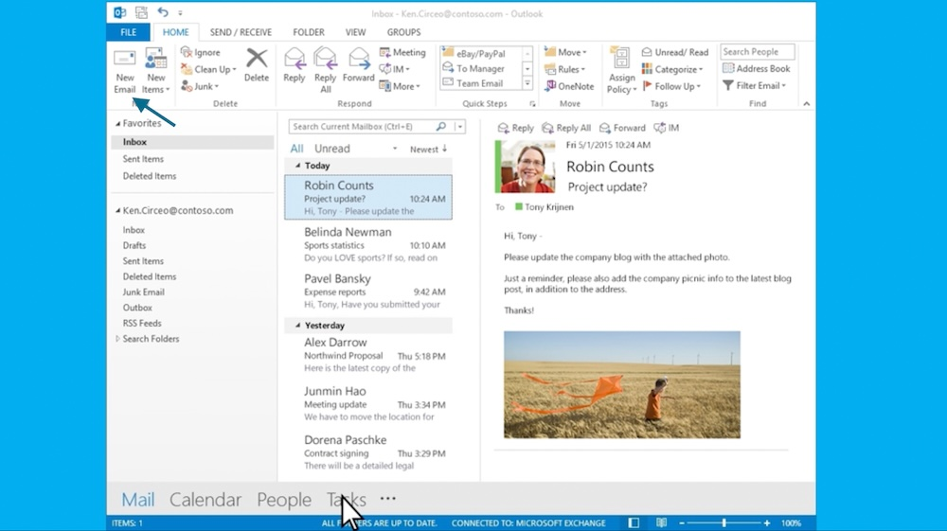

Step 2: Choose “Signature” Under the Message Tab
Once you’ve opened a window to compose a new email, click on its Message tab on the upper left corner next to the File tab, and then choose Signature > Signatures. This will open up the Signatures and Stationery window, which is where you’ll add your email signature.
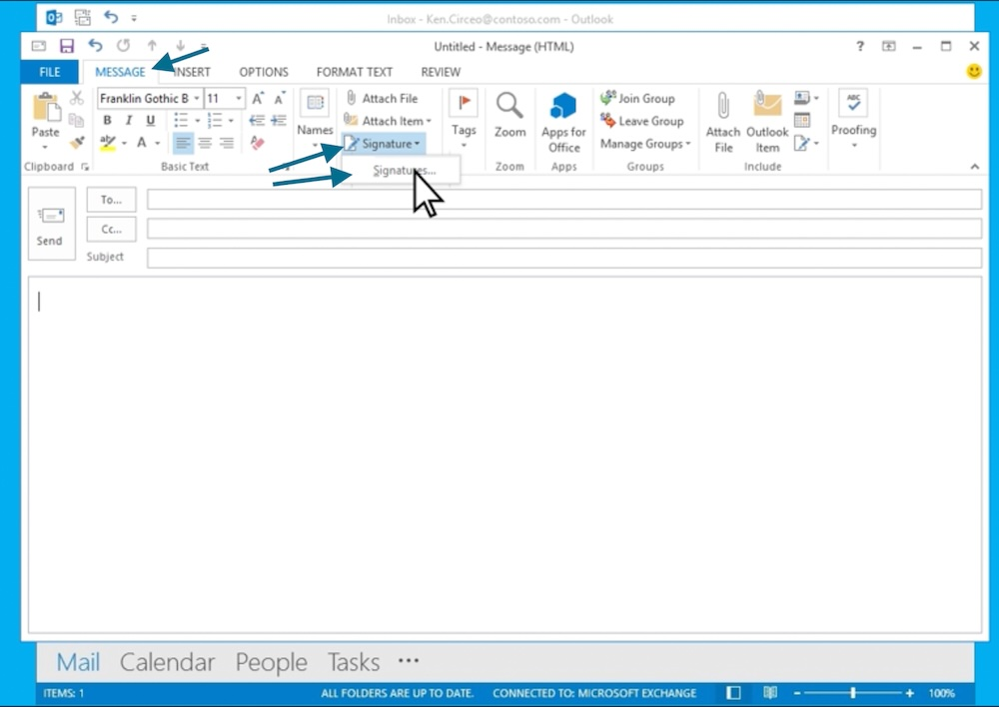

Step 3: Add Your Onsite Email Signature
After you’ve opened up the Signatures and Stationery window, you can directly add your signature. Outlook’s classic version also allows for text or image-based signatures or a combination of both. First, you’ll need to create a name for your signature. Click on “New,” and then type in a name for your signature in the pop-up window. Then, click “OK” once you’re done.
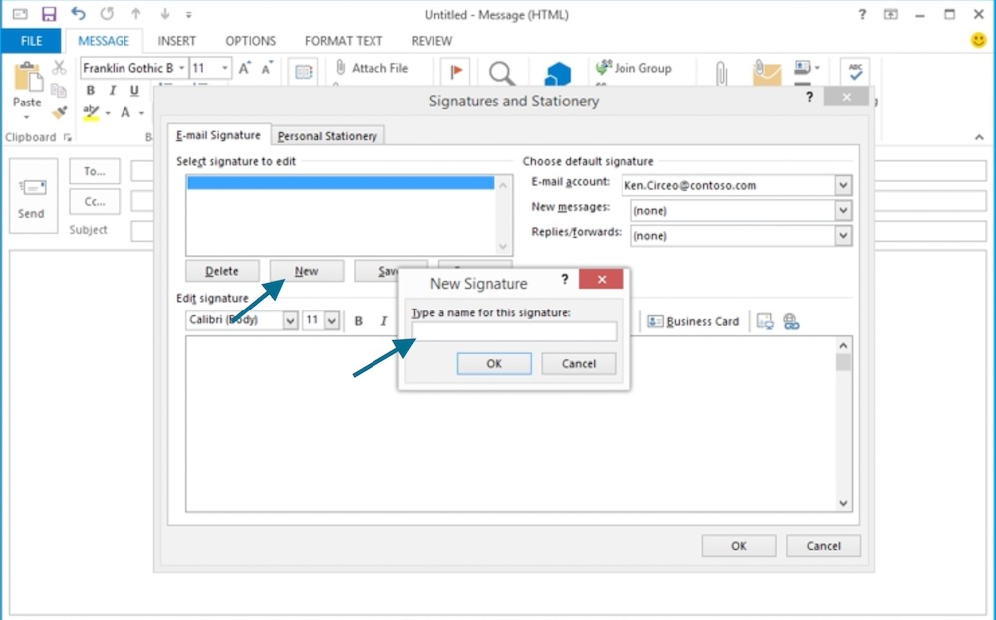

Adding a signature name under the Signatures and Stationery window in classic Outlook. To add a new email signature, click New, then type in your signature’s name. (Source: Microsoft)

Once you’ve saved your signature’s name, it’ll appear in the window. You can then type in your signature in the box, or upload an image file. Then, click “OK” on the lower right corner when you’re done, and your signature will automatically be saved.
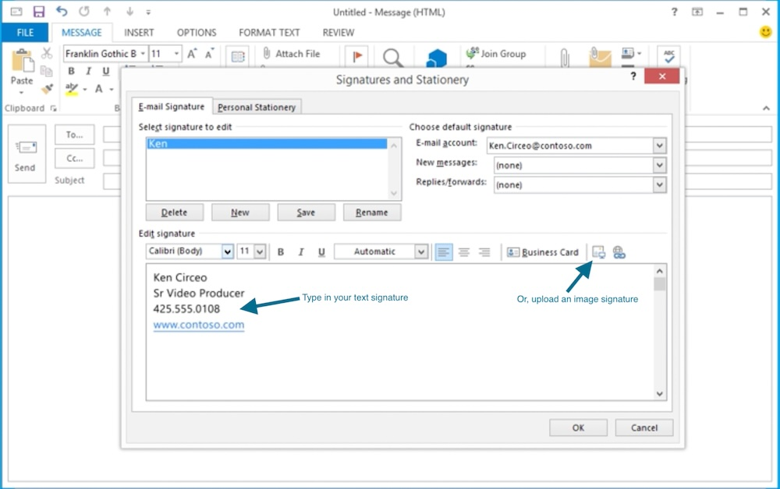

Step 4: Set Your Signature’s Conditions
Before saving and finishing your signature, you can also set its specific conditions, such as from which email account you want your signature to appear, and whether it’ll appear on all messages and replies, emails you forward, or only in new emails you send. You can set these options in the dropdown arrows on the upper right portion of the window.

Setting your email signature's conditions in classic Outlook.
Set your signature’s conditions in the upper-right corner. (Source: Microsoft)

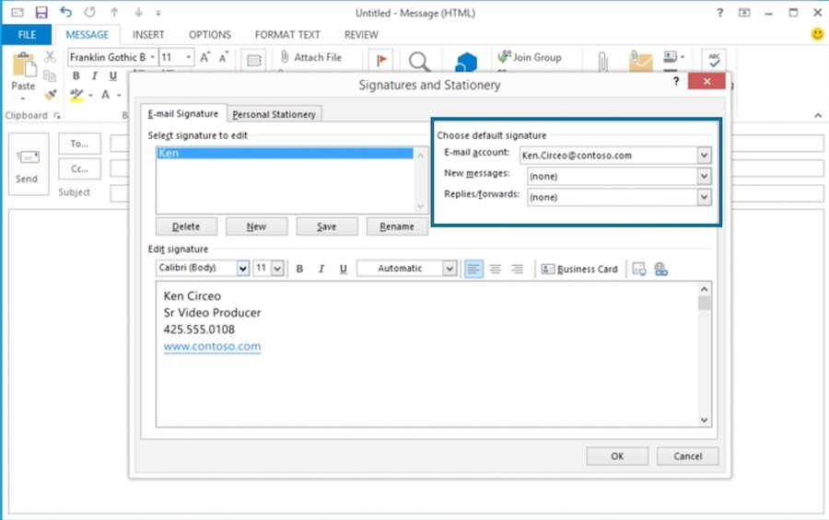

Step 5: Save & Use Your Signature
After setting your signature’s conditions, your email signature is ready to go. Click the OK button on the bottom right of the window, and Outlook will save your signature. The next time you compose a new email, your signature will automatically show up according to the conditions you set.
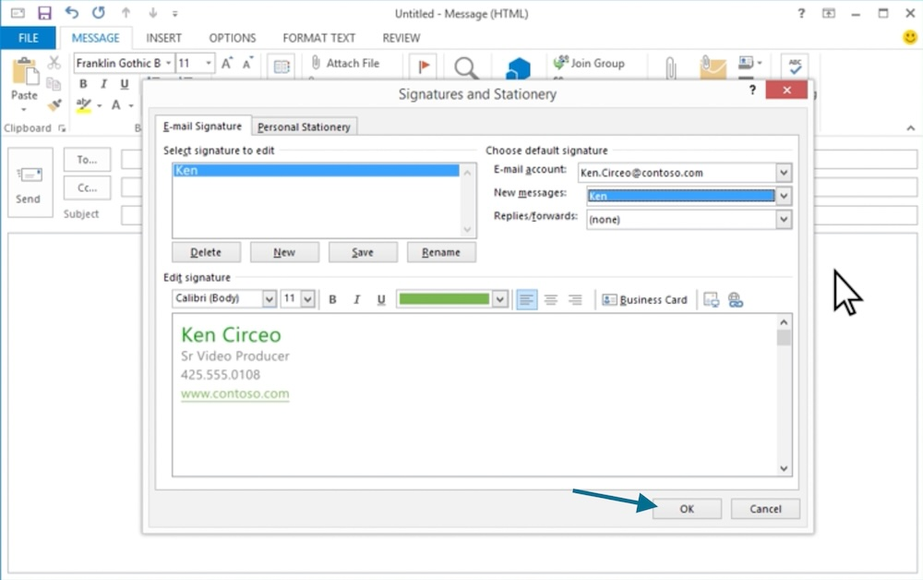

Anytime you need to edit your signature or add any new ones, you’ll only need to visit the same Signatures and Stationery window from your Message tab. You can also easily switch between signatures or delete any unnecessary ones from the same tab.

